CSA0501-DATABASE MANAGEMENT SYSTEMS
LAB EXPERIMENTS DATE: 14-07-2026

EXPERIMENT 4 -- DML Commands (UPDATE, DELETE)

AIM:
To perform Data Manipulation Language (DML) commands such as UPDATE and DELETE in the Flight Reservation System tables.

PROCEDURE:
1. Open MySQL Workbench and select the Flight_Reservation database.
2. Ensure the Passenger table contains sample records.
3. Use the UPDATE command to modify existing records.
4. Use the DELETE command to remove selected records.
5. Use SELECT statements after each operation to verify the changes.
6. Observe the output of each DML command.

PROGRAM:

1. Update the Passenger Name whose Passenger_ID is 101
UPDATE Passenger
SET Passenger_Name='Rahul'
WHERE Passenger_ID=101;
SELECT * FROM Passenger;

OUTPUT:
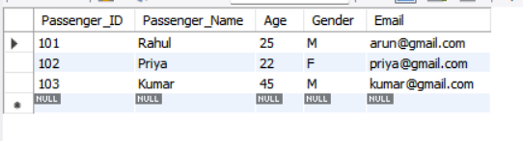

2. Delete the Passenger whose Passenger_ID is 102
DELETE FROM Passenger
WHERE Passenger_ID=103;
SELECT * FROM Passenger;
OUTPUT:
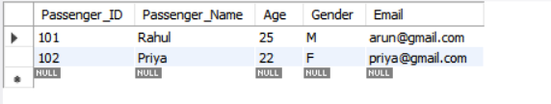

3. Update the Passenger Age to 30 whose name is 'Rahul'
UPDATE Passenger
SET Age=30
WHERE Passenger_Name='Rahul';
SELECT * FROM Passenger;

OUTPUT:
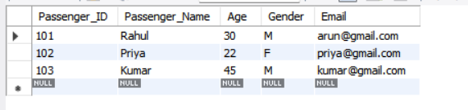

4. Delete all Passengers whose Age is greater than 60
DELETE FROM Passenger
WHERE Age>60;
SELECT * FROM Passenger;

OUTPUT:
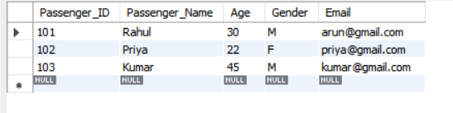

RESULT:

Thus, the Data Manipulation Language (DML) commands such as UPDATE and DELETE were successfully executed and verified in the Flight Reservation System.

